DATA PROTECTION PRIVACY NOTICE – WRITTEN CONSENT

PLEASE READ THIS BEFORE COMPLETING THE FORM

At St Martin-in-the-Fields Charity we are committed to protecting and respecting your privacy and all personal data is held by us and processed in accordance with data protection legislation.

Legal basis
We take your personal data for the purposes of our legitimate interests of being able to make a grant decision, make payments, and for monitoring and evaluation of our grant programme. Where we collect your special categories data, we use it on the basis of your explicit consent, for our decision making process.

The data controller is St Martin-in-the-Fields Charity of Trafalgar Square, London WC2N 4JJ. This privacy notice is in respect of data shared with us (St Martin-in-the-Fields Charity) in our capacity as data controller.

Q: Why do I need to read this notice?
A: Because by law, we are required to explain to you how we use the information that you provide to us.

Q: How will you use my personal data?
A: We will collect your personal data only if you consent to share it with us and we use it to:

- administer your grant application for the purposes of our legitimate interests of providing crisis grants to support people at risk of homelessness.
- evaluate the Fund for the purposes of our legitimate interests of evaluating the effectiveness of our activities.
- Please note that we will never share your personal data with a third party except where there is a legal obligation for us to do so, for example, to protect someone from harm or where it is needed for crime prevention purposes.
- We also use anonymised data to improve our grant programme and to raise more funds for the purposes of our legitimate interests of being able to help more people.

We may also speak to other people at your support organisation including your worker’s line manager.

Q: What is ‘Personal Data’?
A: It is any kind of information about you.
Here are some examples of the kind of personal data which we may ask your support worker about you so that we can process your grant application. This data will help us decide if you can receive a Fund grant.
- Your name
- Your postal address/email address
- Your phone/mobile number
- Information about your circumstances

We also collect information about any health issues or disability that you might have. This is used to decide whether we will give you a grant.
Q: What are ‘Special Categories’?
A: This is information about ethnicity, gender, sexuality, health and disabilities. There is an optional form at the end of our application form that you can use to give us this information. We use this data to check if we are awarding grants to a wide range of people.

In the main part of the application, your worker may give us information about your mental or physical health, disabilities, criminal convictions, or substance use. This data, only if given in the main part of the application called ‘Client circumstances’ might be used to decide if we award a grant.

Q: How long will you keep my personal data for?
A: for as long as is necessary for us to fulfil the purposes explained to you and to meet our legal and regulatory obligations. After two years the information will be securely and permanently destroyed.

Q: What are my rights?
A: Data protection legislation gives you the following rights:
- To be sent a copy free of charge of the data we have about you
- To correct wrong data we have about you
- To reduce or restrict data we have about you
- To erase data we have about you
- To limit what we do with your data including being included in anonymous statistics
- To complain to the Information Commissioner’s Office
Q: What if I change my mind?
A: If you wish to withdraw your consent for us to hold your information please let us know in writing or by email. However, this may mean that we will no longer be able to continue with your grant application.

For further information:
If you have any questions about the information contained on this form or if you believe that any details we hold for you might need updating please contact us on the address below or email us at: vrf@stmartinscharity.org.uk or phone
020 3795 5746 (voicemail only)
.

St Martin-in-the-Fields
Trafalgar Square
London
WC2N 4JJ
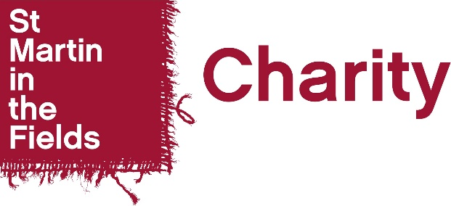

VRF
Privacy Notice and Consent Form for Applicants
WRITTEN CONSENT

A VRF grant is not guaranteed. We receive many applications per day and don’t have the funds to approve all of these. Our decisions are final.
You can withdraw your consent for us to hold your information. Please let us know in writing or by email.
This form is for WRITTEN CONSENT ONLY and cannot be completed using electronic signatures. If it is not possible for your client to physically sign the form, please obtain verbal consent and use the VERBAL CONSENT form only. Using the incorrect form will result in your application being returned.

Please note: consent forms need to be dated within the last 3 months otherwise they won’t be accepted.

To be completed and signed by the client

All boxes need to be ticked otherwise we will be unable to assess your application.

I ________________________________ (Name of client) __________________________________________________(Address – if your client is of no fixed abode, please write ‘NFA’) confirm that:

I have read about and fully understand how and accept that my personal data including special categories data will be used by St. Martin-in-the-Fields Charity when my support worker applies for a VRF grant for me.
I give my fully informed consent for St Martin-in-the-Fields Charity to use my special categories personal data as explained in the Data Protection and Privacy Notice.

Signed:_______________________ (signature of client)
Date: _______________________ (date signed by client)

