Frontline Network Three-year Local Network Partnership opportunity (August 2021-July 2024)
Expression of Interest
Stage 1 Deadline 5pm- Thursday 11th March 2021
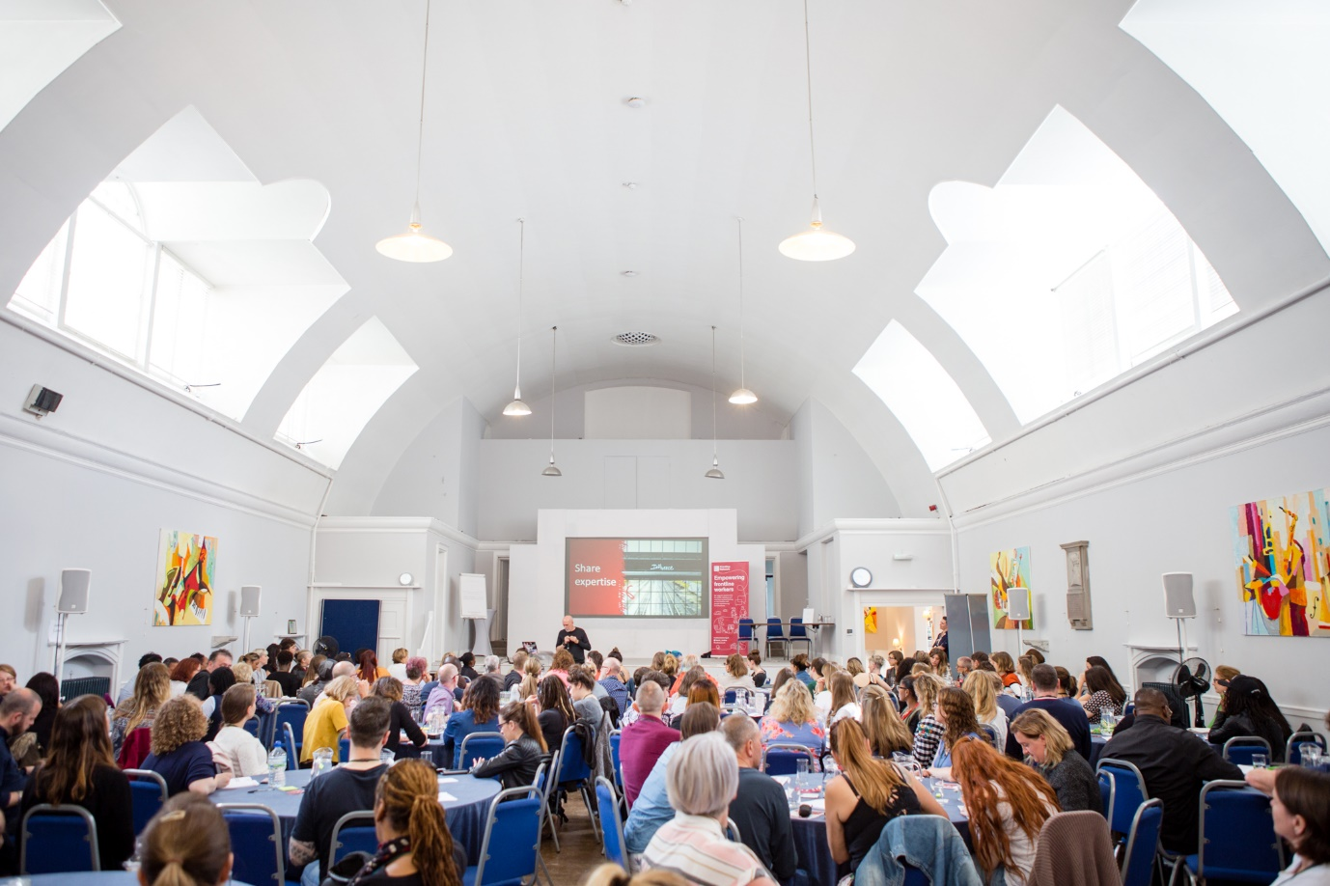
If you have any questions about the application process, please don’t hesitate to contact Amanda Bennett, Partnerships Manager on frontline@stmartinscharity.org.uk
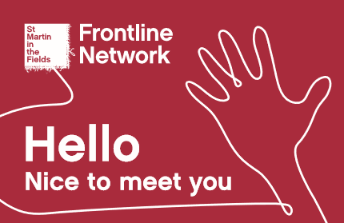

Who we are and what do we do?
Would you like to be part of a UK-wide community of organisations, who are supporting frontline workers to network, share expertise and reduced siloed working in their local communities? Passionate about affecting change, raising awareness of issues impacting frontline staff and people they support who are experiencing homelessness? Then please read on….
The Frontline Network launched in June 2016, and works at a national and local level to empower frontline workers across the UK. At a local level, we provide regular opportunities to bring together frontline staff to network, share experience and expertise and link to decision makers. We do this via our community of 8 Partner organisations. Anyone who is a paid frontline worker in the voluntary, statutory and public sector can register with the Network.

We are looking for three new Partners!
We are seeking three new Partner organisations to join our community of local networks; one in Northern Ireland and two in England. We are particularly interested to hear from organisations in South Yorkshire, who would be interested in continuing our South Yorkshire Frontline Network.
As a Partner, you enable us to understand what is happening in your local environment; to see how national polices are impacting frontline staff and the people they are working with. You help us draw out key learning/ solution-focused approaches from frontline staff; to improve both their experiences as well as for the people they are working with experiencing homelessness. As a Partner, your role is to:
- Provide opportunities for frontline workers to regularly come together in your local area- to network, share experience and expertise

- Explore potential solutions on key issues affecting frontline staff and people they are supporting

- Build links between frontline workers and decision-makers to influence change in their areas

Why join our Partner community?
To support you in your activities as a Local Network Partner, we can provide up to £20,000 per year, for 3 years. This supports you to organise regular networking opportunities and information sharing amongst frontline workers in your area.

Adapting our approach during Covid-19
Due to Covid-19 restrictions, our Partners are currently unable to provide any in-person events. All activities have been adapted to an online offer to bring together frontline staff. These sessions support connections with frontline staff, explore how practice is adapting, offer thematic training workshops, local updates; engaging frontline staff across multiple areas and an opportunity to influence decision makers remotely.
Whilst funding would normally cover event costs such as venue hire, refreshments, guest facilitators and other associated staff costs, these can be adapted to include online platforms costs until we are able to safely resume in-person events again.
We also provide you with the following tools to support your role in facilitating networking:
- Frontline Network Partner logo, for use on all promotional materials
- Partner email signature
- Monthly E-news Mailchimp template
- Blank business cards for networking purposes at events
- Branded postcards that promote our national resources/ outline your local network
- Regular online or in person catch ups with all Partners- to share learning and updates from local network areas and the national Frontline Network; to strengthen our partner community.
We have worked hard over the last 3 years to build a Partner community of like-minded organisations. This provides opportunities to support each other, share experiences, network and seek advice from one another. We can also provide:
- Choice and flexibility in how you report on your activities to us- from quarterly to 6-monthly, written or via in-person meetings

- A specific point of contact to support and guide you via our Partnerships Manager

- Support with your Communications and any Policy work via our Policy and Comms Officer

How you can apply?
Our application process has two stages.
- Stage 1: submit an expression of interest. Please complete the questions on pages 6-7 and email these to amanda.bennett@stmartinscharity.org.uk by 5pm on Thursday 11th March 2021.

- (Please note- during our first stage shortlisting process, we may contact you with queries on your application form.)

- After the deadline, we will invite shortlisted organisations to submit a stage 2 full application. This will include an action plan and budget breakdown relating to your planned activities/ approach. The deadline will be in 5pm on Thursday 13th May 2021.

- If you are successfully shortlisted, we will contact you to arrange a video call with you and talk through your application/ approach.

- We aim to have a final decision for our three new Partners by end of July 2021.
(Please note- the above timeframes may be subject to change.)
If you have any questions or would like to contact us about this opportunity before submitting an application, you are welcome to contact our Partnerships Manager Amanda Bennett, on amanda.bennett@stmartinscharity.org.uk or call 07724561072.

A bit about how we currently work
As a Partner, you would organise regular opportunities to bring together frontline staff in your area to network, share experiences/ expertise and link to local decision-maker to support influencing change.
Our Partners organise regular events that are steered by what people working on the frontline want and need. This has resulted in increased networking, multi-agency, multi-sector working, and collaboration at a local level.
Local Network themes have included:
- Wellbeing on the frontline
- Universal Credit
- Homeless Reduction Act (HRA)
- Experiences of death
- EU Settlement Scheme and Migrant related experiences of homelessness
- Health and homelessness
- Asset and strengths-based approaches
- Access to accommodation
- Consultations on Section 21 and the HRA
- Calls from the Frontline- Scottish Government consultation on how £50m should be spent to tackle homelessness over 5 yrs
Learning is drawn from comments, discussions and feedback forms at their events, and has been shared with local commissioners/ decision makers to support influencing change.
One example is our Coventry Frontline Network’s work to influence local decisions. This included collecting the views of frontline staff on their local Severe Weather Emergency Protocol (SWEP) process and thoughts on how to improve this. Suggestions included having a transparent policy of what would trigger SWEP, who owned that decision, along with more public visibility of SWEP. When the council convened a group to review SWEP, they were able to use their work to help those discussions, resulting in a document that clarified who had responsibility for SWEP, how and when it would be triggered and how this is communicated across the City.
Our Partners also support us with highlighting our national resources of Funding, Community and Resources and how frontline staff can access these additional resources to support them in their roles.
We have developed our resources from speaking with frontline staff and listening to what they tell us they need. It’s not about us, it’s about people working on the frontline.
For example, as a result of frontline workers telling us in our Frontline Worker Emergency Fund Survey about their experiences of responding to Covid-19, how this was impacting people experiencing homelessness as well as the impact of this on their organisations, we launched our VRF Emergency Fund. The fund provides support around three areas of- basic essential need, overcoming barriers to support and securing accommodation. To ensure this support is as effective as possible, we have deliberately maintained a flexible funding approach; in recognition of what frontline staff and people they support old us was needed.

Expression of interest- Frontline Network Partner application form

Organisation name

Lead contact name

Role

Email

Contact telephone

Address

Charity registration number

Tell us about your organisation- what do you do?

Why would you like to become a Partner of the Frontline Network?

What are some of the key issues affecting frontline workers in your local area?

Are there any current opportunities for frontline workers to share their experience and influence local decision makers online?

How would you bring together frontline workers in your area via regular online/ in-person events?

How would you bring together frontline workers in your area to share learning with local decision makers whilst working remotely?

Do you think being a Partner of the Frontline Network would support your organisation’s wider work?

Do you have any questions for us at this point?

Thank you very much for your interest in this opportunity!

